Step 1: Run VMWare Workstation Pro & Click on New and select typical.

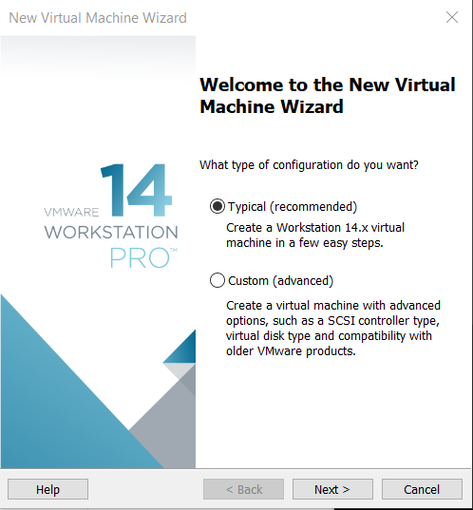

Step 2: Select image file(iso)option and browse to that file and open it.

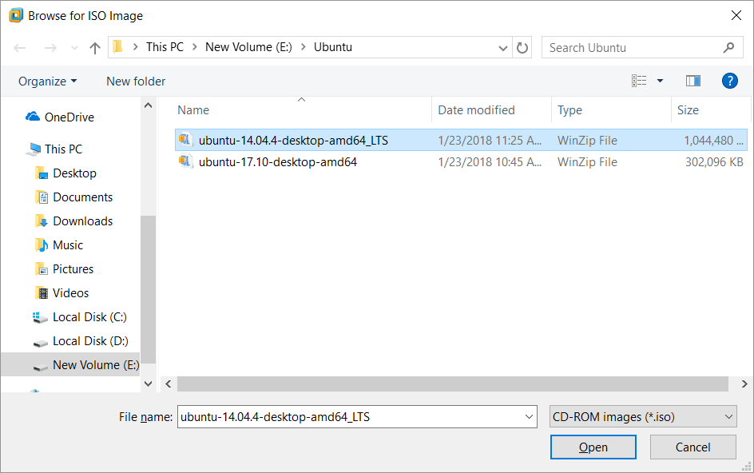

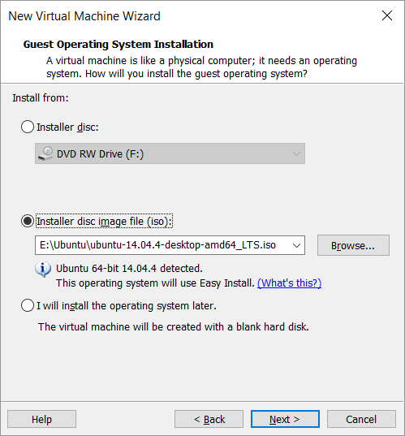

Step 3: Give Name and login credentials for the VM

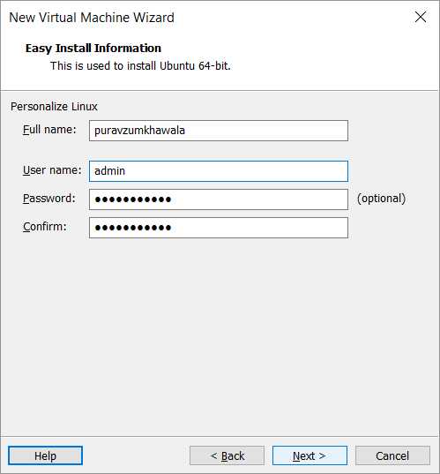

Step 4: Give name of your VM and location for its files to be stored

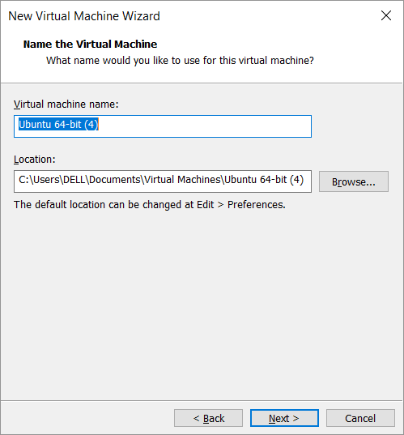

Step 5: Select the maximum storage capacity and select split virtual disk into multiple files.

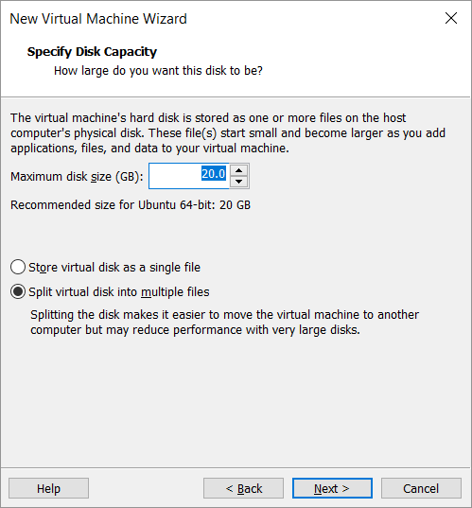

Step 6: Customize your hardware according to your need eg. RAM close it and press finish.

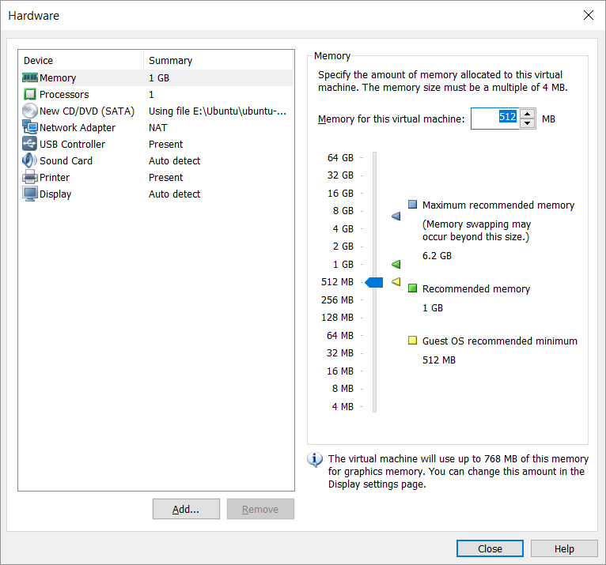

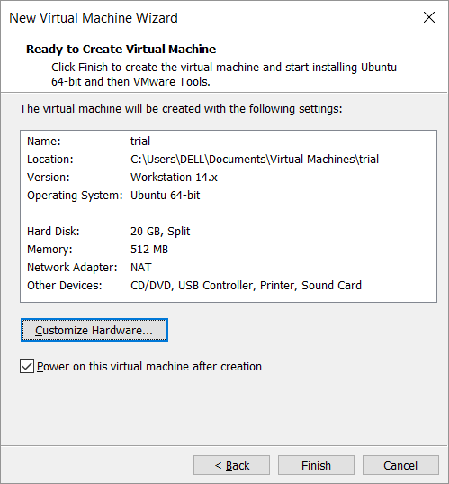

Step 7: When powered on files start copying and configuration begins

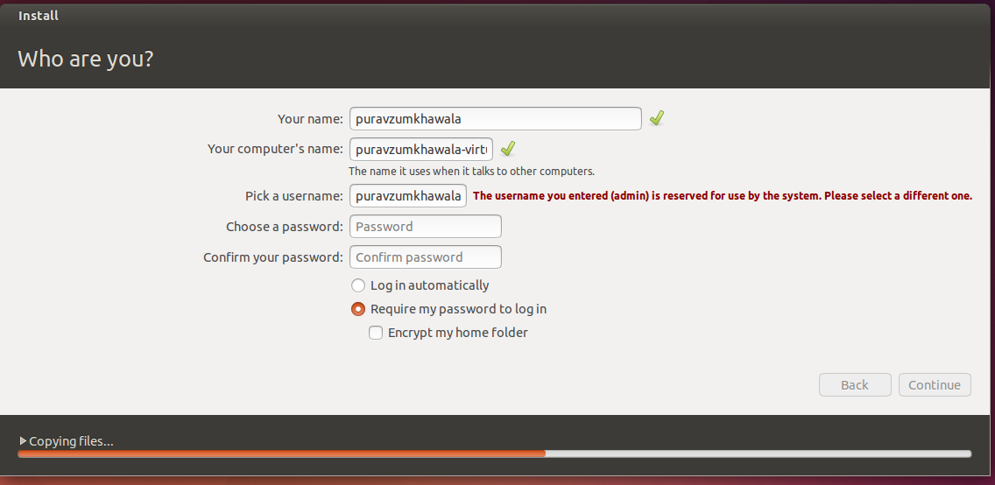

Step 8: Launch System by pressing continue.VM ready to use.

